Getting the most out of Microsoft Edge

Microsoft Edge, the new browser in Windows 10, is designed to deliver a better web experience. It’s faster, safer, and more productive—designed to work the way you do and help you get things done through easy sharing, reading, discovery, and more.

# Browsing with Microsoft Edge

Microsoft Edge makes it easier to search and browse the web. Just enter a URL or search term in the handy address bar. You’ll be redirected to your site or get search suggestions and results from the web, your browsing history, and your favorites—all right on the spot.

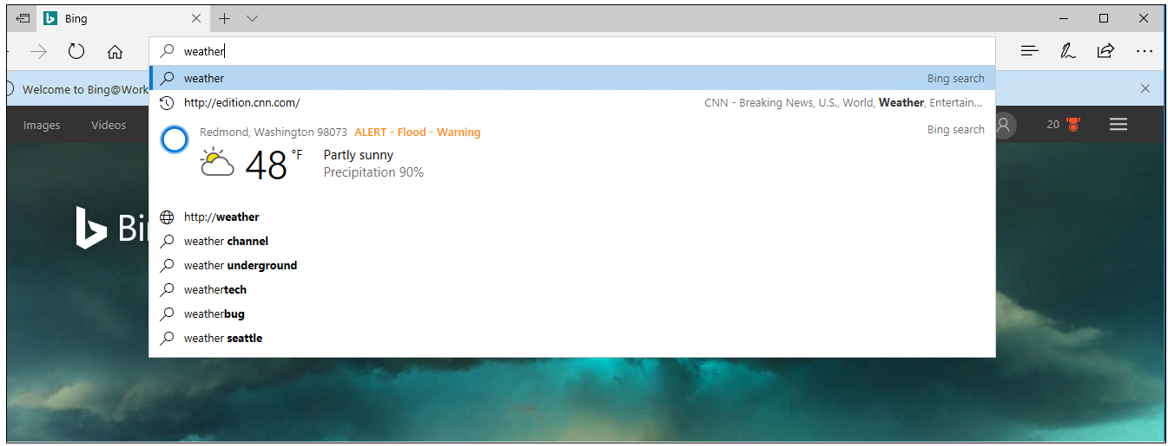

## Use “Paste and go” and “Paste and search”

With the new **Paste and go** feature, you can copy any link into your clipboard, right-click in the address bar, and choose **Paste and go** from the context menu. Microsoft Edge pastes the URL into the address bar and navigates to the site. If you copy something other than a link to your clipboard, you will instead see **Paste and search**, which will launch a web search instead.

## Open a new Microsoft Edge window with ease

Need a new Microsoft Edge window? Just move your pointing device over the Microsoft Edge icon Microsoft Edge icon on the Windows taskbar, and select the middle button (on a three-button mouse or trackpad) or tap the scroll wheel on your mouse, and a new window opens.

# Using What’s new and tips with Microsoft Edge

Need to know what’s new in Microsoft Edge? Select **Settings and more**  Settings and more icon and then select **What’s new and tips.** You’ll be directed to theMicrosoft Edge Tips page where you can see what’s new in Microsoft Edge and stay more productive, organized, and safe.

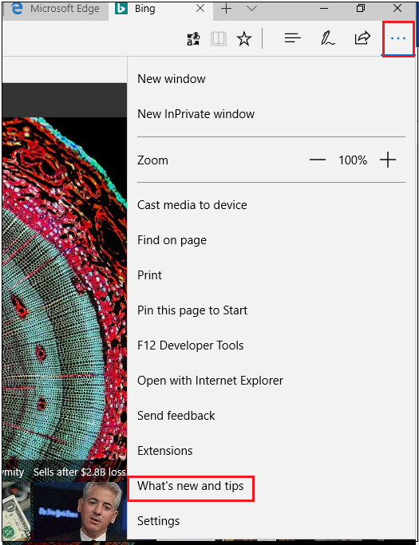

# Using the Hub

Think of the Hub as the place where Microsoft Edge keeps the things you collect on the web—including your favorites, reading list, books, browsing history, and current downloads.

* To open the Hub, select **Hub** Hub icon .
* To change views, select a button at the top of the Hub: **Favorites** Favorites icon, **Reading List** Reading list icon, **Books**Books icon , **Browsing History** History icon, or **Downloads** Downloads icon.

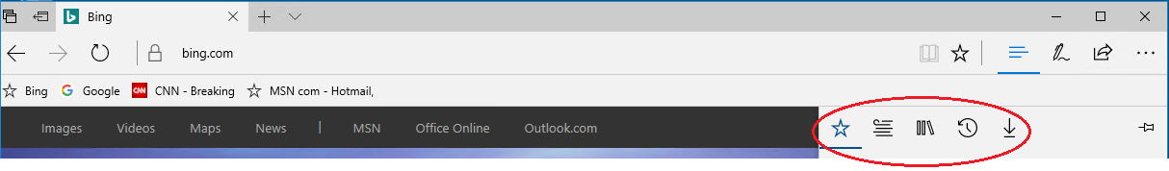

# Making Web Notes

Microsoft Edge is the only browser with built-in inking that lets you take notes, write, doodle, and highlight directly on webpages. You can add a few secret ingredients to a recipe to share with your fellow amateur chefs, collaborate on a new project with your coworkers, or have fun with your kids—and then save your Web Note for later or share it with others.

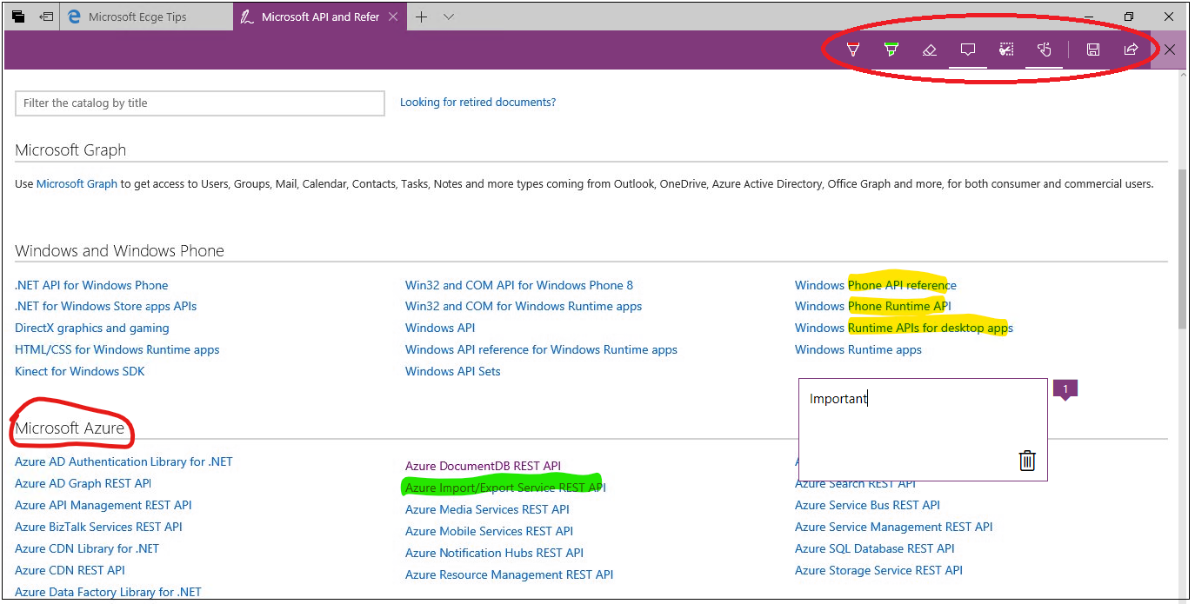

Select **Make a Web Note**  to display the Web Note toolbar, and then you can:

* Select **Draw**  Draw icon to draw on the page. When the **Draw** tool is active, select it again to adjust color or tool size.
* Select **Highlight**  Highlight icon to highlight content on the page. When the **Highlight** tool is active, select it again to adjust color or tool shape.
* Select **Erase** Erase icon to erase everything you’ve added using the **Draw** and **Highlight** tools. When the **Erase** tool is active, select **Erase** again, and select **Erase All**.
* Select **Add a typed note** Add a typed note iconto add a comment, select the place on the page where you want to anchor the comment, and then enter the comment.
* Select **Clip** Clip icon to clip part of a page, and then drag to select the region of the webpage you want to clip. Release your finger or mouse, and then to save, share, or copy what you clipped, select the **Save** button that appears next to the clipped region.
* Select **Touch writing** Touch writing icon on the **Web Note toolbar** to enable touch experience.

When you’re done creating a Web Note, you can:

* Save iconSelect **Save** Save icon on the **Web Note** toolbar to save the Web Note to your Favorites, Reading List, and OneNote.
* Select **Share** on the **Web Note** toolbar to share the Web Note via OneNote or to your Reading List.
* Select **Exit** on the **Web Note** toolbar to close it and return to the normal view.

# Getting around with Cortana

Only Microsoft Edge has Cortana—your personal digital assistant—right in the address bar. She's there to help you do things faster and easier, like make reservations and get at-a-glance directions to the perfect dinner spot.

When Cortana has information that may be useful, you’ll see the Cortana icon Cortana icon in the Microsoft Edge address bar.

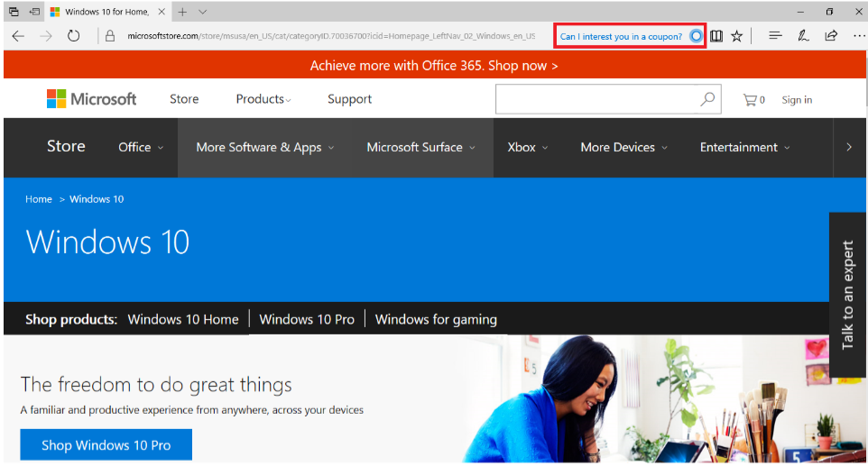

Selecting Cortana Cortana icon will show you details on the right side of the screen. Click anywhere on the web page to close the details pane.

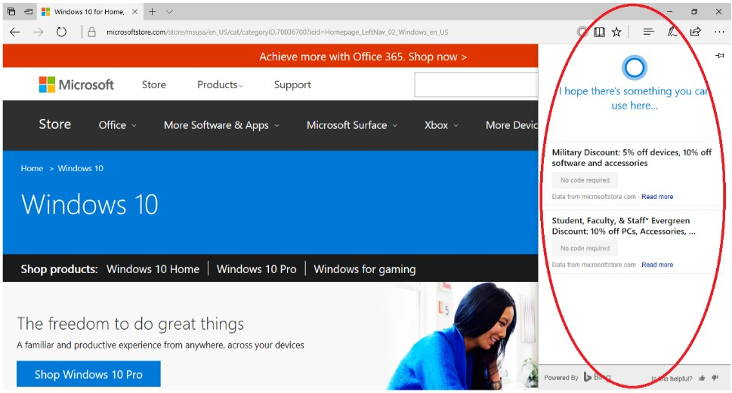

## Ask Cortana about content on a webpage

1. Select a word, phrase, or image on the webpage.
2. Press and hold (or right-click) the selected content, and then select **Ask Cortana**.

Cortana appears on the right side of the screen with information that may be useful.

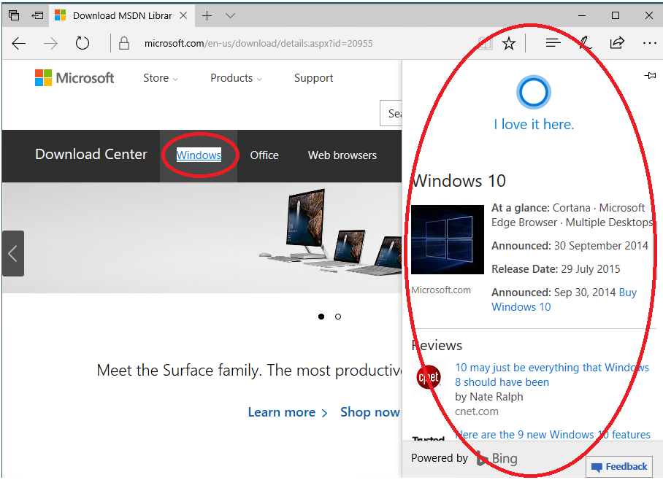

# Making a Reading List

Reading List gives you a place to save content that you want to read later.

## Create a Reading List

* To save content to a Reading List, select the **Favorites** icon Image of Add to Reading list icon **>** **Reading List** **> Add**.
* When you’re ready to read what you’ve saved, go to the **Hub** Hub icon , and then select **Reading List**  Image of Reading list icon.

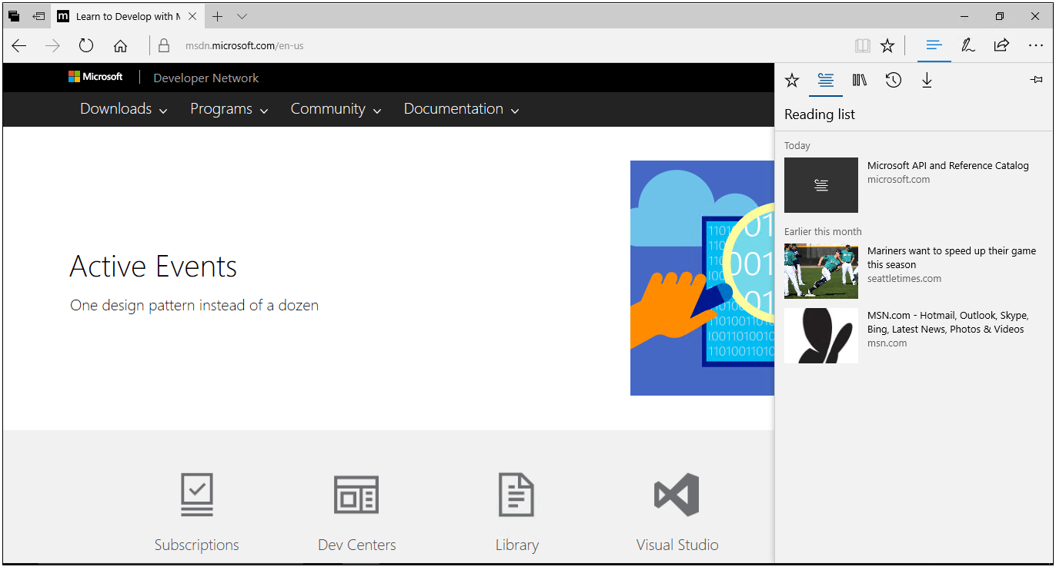

## Turn on roaming for your Reading List and Favorites

Your Reading List and Favorites will roam across your PC and Windows 10 Mobile devices when you are connected using your Microsoft account (Outlook.com, Live.com, or Hotmail.com).

1. Select Settings and more icon **Settings and** **more** in the upper-right corner.
2. Select **Settings**.

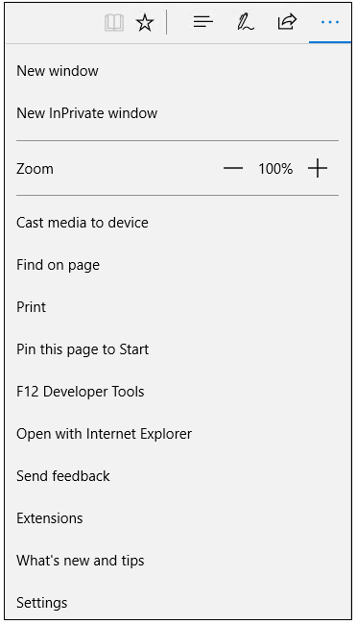

1. Switch the toggle under **Sync** to **On**.

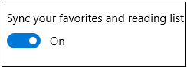

# Managing Favorites

Saving a site as a Favorite is a simple way to remember sites you like and want to visit often.

Right-click on the Favorites Bar to select new menu options:

* Streamline your Favorites Bar by choosing to **Show icons only**.
* **Rename items** on your Favorites Bar.
* **Create new folders** to organize your Favorites.

If you would prefer to remove browsing data, you can select More icon **More**, then **Settings**, then **Choose what to clear** under Clear browsing data**.** After selecting options for data you want to remove, you can select **Clear** to remove the data one time, or you can select **Always clear this when I close the browser**.

## Save a Favorite

1. Go to a website you want to add as a Favorite.
2. On the toolbar, select **Add to Favorites or Reading List** Favorites icon .

Favorites toolbar

The name of the page appears in the **Name** box, but you can change it to something more friendly.

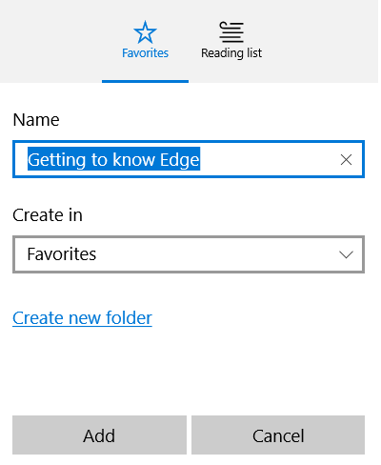

1. By default, your new Favorite is created in the **Favorites** folder, but you can put it on the **Favorites bar**, in a custom Favorites folder, or select **Create a new folder**, and then save it there.
2. Select **Add**.

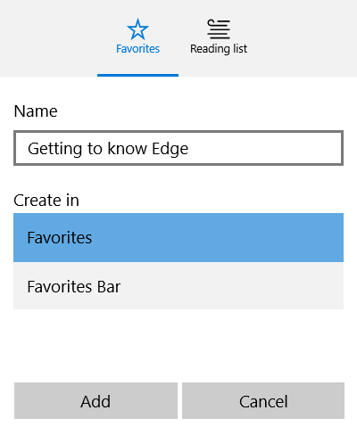

## Import Favorites

To import Favorites from another browser, follow these steps:

1. Select **Favorites** Favorites icon.  
   -OR-  
   If **Favorites** is not shown, select the **Hub** Hub icon, and then select **Favorites**Favorites icon.
2. Select **Settings**.
3. Select **Import from another browser** under the **Import favorites and other info** header.

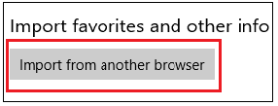

1. Choose the browser from which you want to import your Favorites.

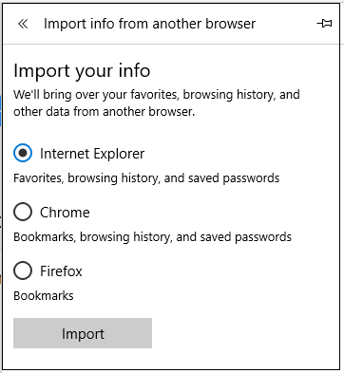

1. Select **Import**

## Import/export Favorites to/from an HTML file

Microsoft Edge has a new feature to export/import Microsoft Edge favorites to/from an HTML file. This feature helps you to backup Microsoft Edge favorites and also allows you to import favorites from an HTML file to Microsoft Edge browser.

1. Select **Settings and more**  Settings and more icon and then select **Settings**.
2. Select **Import from another browser**.



1. Select either **Import from file** or **Export to file**.

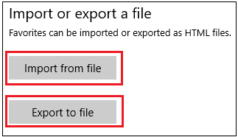

## Open favorites from a folder as new tabs

Microsoft Edge has a new feature to open all your favorite items from a selected folder as new tabs.

1. Select the **Hub** Hub icon, and then select **Favorites**.
2. Right-click a folder, and then select **Open all** option from context menu.
3. Open all favorites from a folder as new tabs.

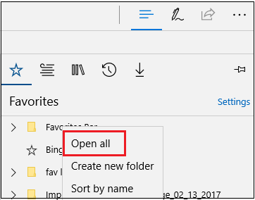

# Downloading and uploading

Microsoft Edge has some new features and improvements to the download and upload experiences:

* You can drag and drop a file to upload to sites, such as OneDrive for Business or SharePoint.
* You can save an image on a page by right-clicking and selecting **Save picture as**.
* You can save a link or other types of items on a page by right-clicking and selecting **Save target as**.
* When you download a file from the web, after the download is complete you can select **Open folder** to see the contents of the download destination folder.

Open folder selected

To change your download settings, select More icon **More** > **Settings** > **View advanced settings**, and then select **Change** under the Downloads header.

# Using tabs with Microsoft Edge

Recent improvements to Microsoft Edge make it easier to see what is on other tabs at a glance, open a new window, and stop annoying loops of new windows and dialog boxes from malicious websites. If you have a touchscreen, swipe navigation features make it possible for you to swipe left or right to navigate forward and backward through your browser history.

## Set aside tabs for later

Microsoft Edge browser has a new feature that will help you quickly manage all your tabs without losing your flow.

1. Select the **Set these tabs aside** icon Set these tabs aside icon on top left corner of Microsoft Edge browser to set tabs that you want again later.

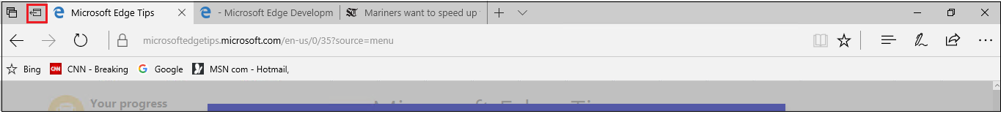

1. To bring the tabs that you’ve set aside, select Restore tabs icon, and then select **Restore tabs**.

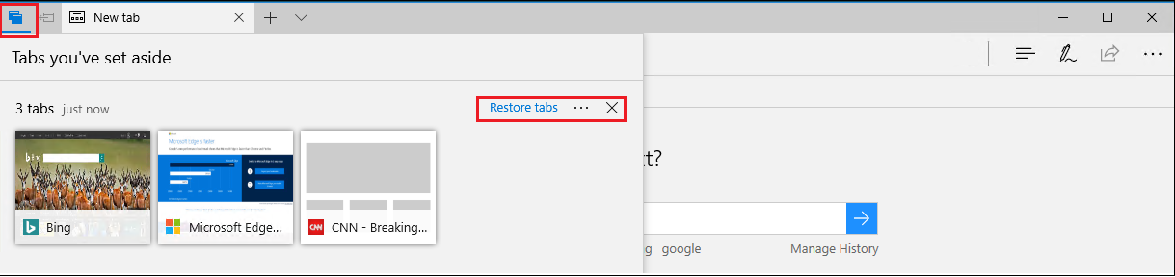

## Tab preview bar

Microsoft Edge browser has a new feature which allows you to easily track what’s in your tabs by providing Tab preview bar which allows you to easily glance at a visual preview of every tab you have open without leaving your page.

1. Select **Show tab previews** Show tab previews icon next to your tabs on Microsoft Edge browser.

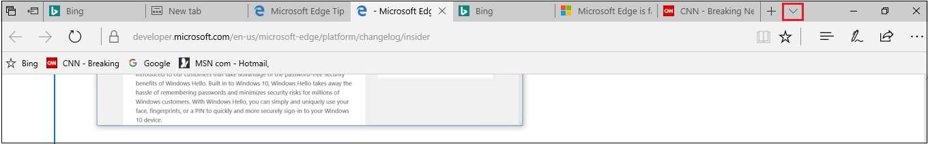

1. Select **Hide tab previews** Hide tab previews icon next to your tabs on Microsoft Edge browser to hide the tab preview.

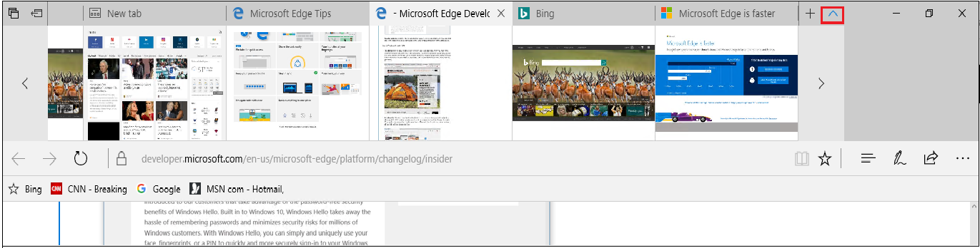

**NOTE:** You can also scroll through the list with touch, mouse wheel, or a touchpad.

## Tab preview

If you have multiple tabs open in your browser, it can be challenging to keep track of what is on each tab. Microsoft Edge introduces tab preview—when you hover or move your pointer over a tab other than the one that is currently active, Microsoft Edge shows you a thumbnail preview of the content on that tab.

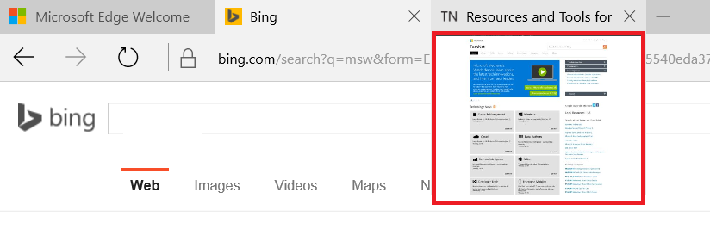

## View your Tab history

* Right-click the **Back** button to see your tab history.

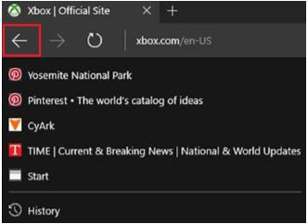

## Pin a tab

* To pin a tab, right-click the tab, and select **Pin**.

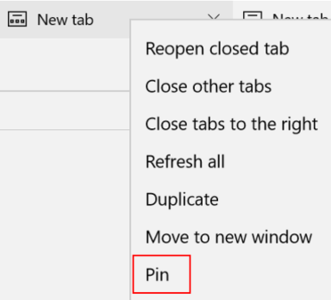

# Using Reading View

Microsoft Edge includes an integrated **Reading View**, which provides a clean and simple layout to help you stay focused on the content.

* Select **Reading View** Image of Reading view icon in the address bar to use this feature. If Reading View isn’t available for a particular webpage, the button will be dimmed.
* To adjust Reading View style and font size, open a website that has Reading View, and then select **Options** (**Ctrl+Shift+O**) Options icon .

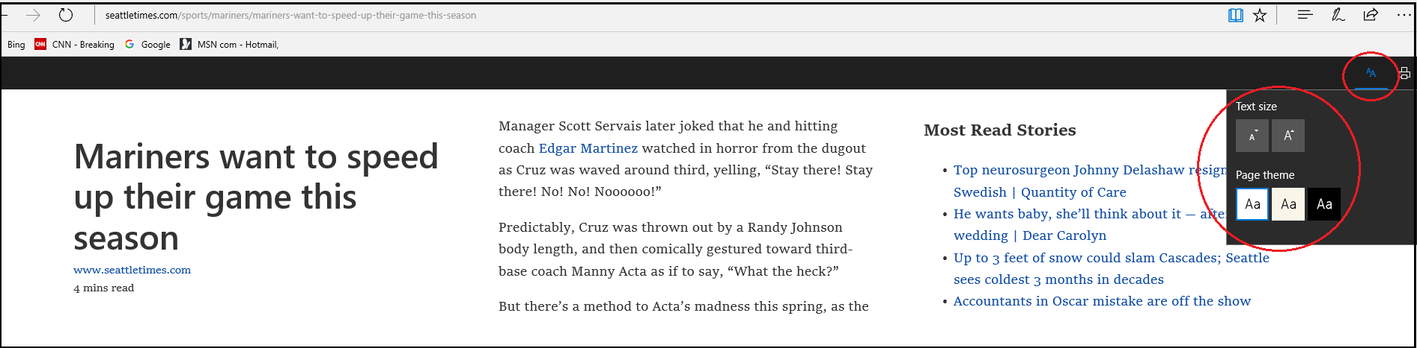

## Read e-books aloud in Microsoft Edge

Microsoft Edge browser has a new feature to shop for your favorite e-books in the Store and read them aloud.

1. Select the **Hub** Hub icon and then select **Books** Books icon.
2. Sign in to the Books section with the same account you use in the Store.
3. Select **Get books**, and follow the instructions to purchase a book from Store.

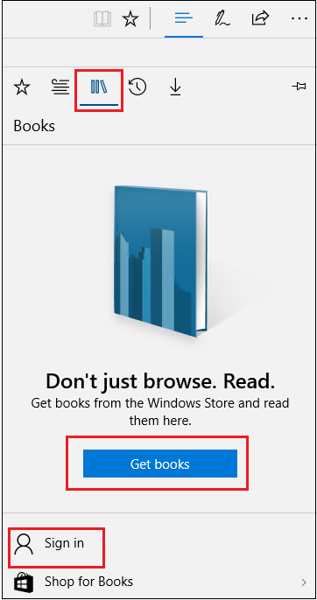

1. Select the **Read aloud** button at the top-right corner after opening one of your e-books, and listen to Microsoft Edge read you the book.

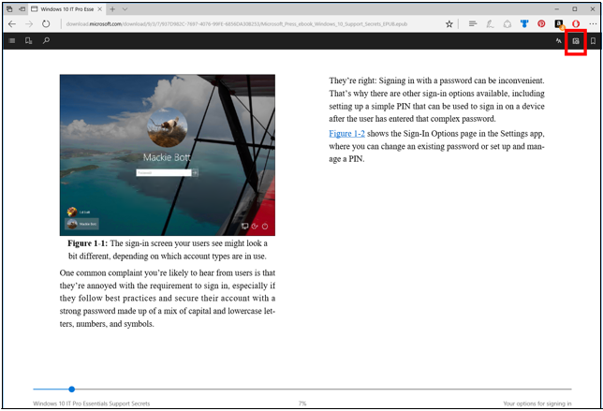

**NOTE:** This feature is also extended to all non-store EPUB files opened using Microsoft Edge.

# Using the PDF reader in Microsoft Edge

Microsoft Edge includes a built-in PDF reader, so you won’t need to download a separate PDF reader app.

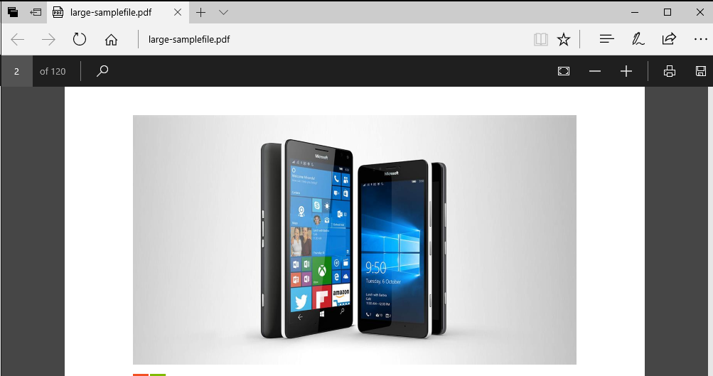

**NOTE:** In addition to being available on a webpage, you can find Cortana when you are reading a PDF document in Microsoft Edge. Just right-click or press and hold on a word or phrase, and then select **Ask Cortana**.

## The PDF reader toolbar brings commands front and center

Now, common PDF commands like **Zoom**, **Print**, **Save**, and the page controls are easy to find and use on a new toolbar.

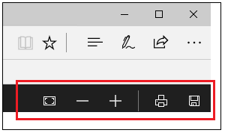

# Opening webpages with Internet Explorer

Microsoft Edge uses a new rendering engine to help you get the most out of modern webpages. If a page doesn’t look quite right in Microsoft Edge, you can open the same page with Internet Explorer—just select More icon **More >** **Open with Internet Explorer**.

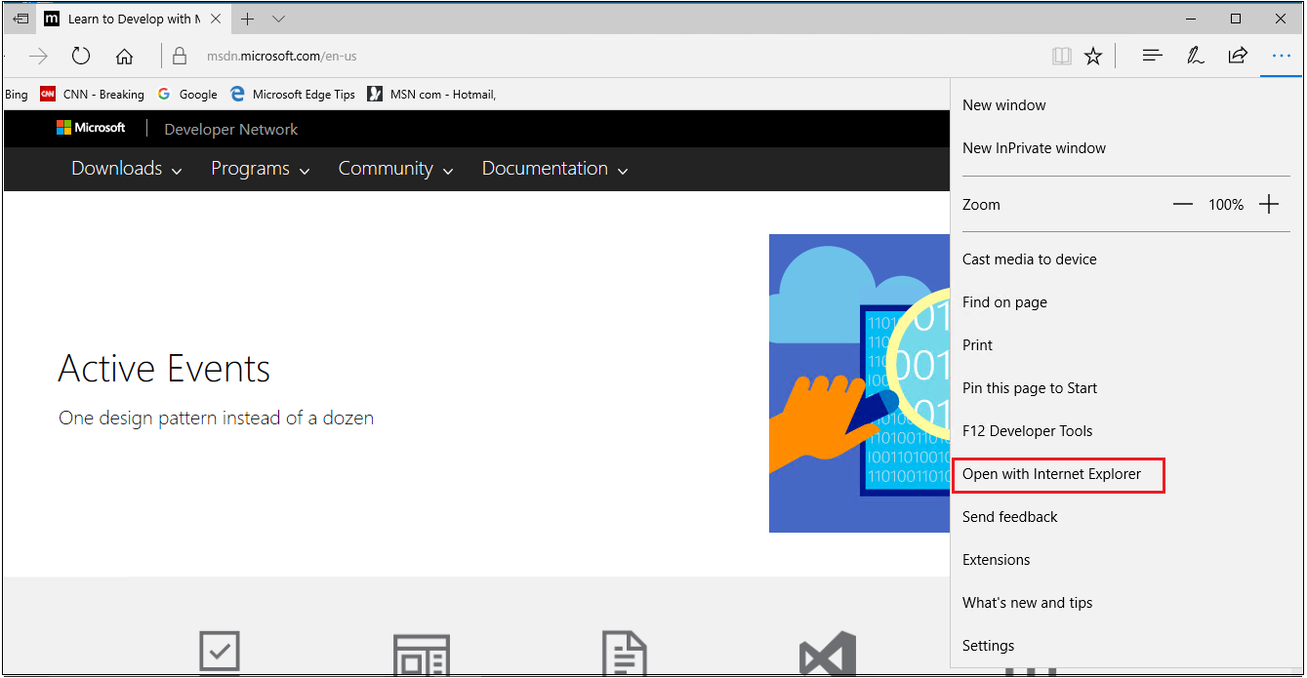

# Getting and loading Microsoft Edge extensions

Microsoft Edge is already great for browsing the web, but now you can add extensions to do even more. Extensions are add-on apps you can get from the Windows Store to add features to your browser.

Some of the functionality that extensions can provide:

* **Interact in new ways with Microsoft Edge**. The Mouse Gestures extension lets you close a tab or refresh a page with a right-click and a flick of the mouse.
* **Add buttons to do things on a particular page**. Some extensions have buttons that only appear in the address bar when it makes sense. For example, the Translator extension will display a button when you visit a foreign-language webpage. Clicking on the button will instantly translate the content to your Windows language.
* **Change the content of webpages you visit**. Some extensions, such as those that block advertisements, work quietly in the background to change the content of the websites your visit.

In the Extensions pane, all installed extensions will be listed, or you can visit the Store to get additional ones. To find extensions and add them to your browser, select More icon **More > Extensions > Get extensions from the Store.**

Install the extensions you want, then switch back to Microsoft Edge and follow the on-screen instructions to turn on the extensions.

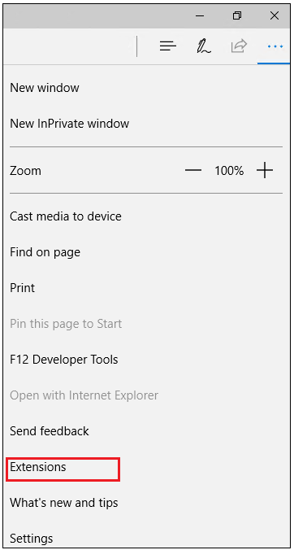

To keep your extensions front and center, select More icon **More** and you’ll see icons for some of your extensions at the top of the menu. Right-click (or press and hold) the icon, and select **Show next to address bar.**

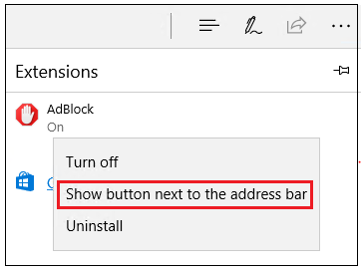

# For more information

## Microsoft IT

[microsoft.com/itshowcase](http://www.Microsoft.com/ITShowcase)

## Windows

<http://windows.microsoft.com>

## Get to know Microsoft Edge

<http://windows.microsoft.com/en-us/windows-10/getstarted-get-to-know-microsoft-edge>

## For more great productivity guidance, visit

<http://microsoft.com/ITShowcase/Productivity>

© 2017 Microsoft Corporation. All rights reserved. Microsoft and Windows are either registered trademarks or trademarks of Microsoft Corporation in the United States and/or other countries. The names of actual companies and products mentioned herein may be the trademarks of their respective owners. This document is for informational purposes only. MICROSOFT MAKES NO WARRANTIES, EXPRESS OR IMPLIED, IN THIS SUMMARY.